Chapter 19, Problem 20.

Find the y parameters for the circuit in Fig. 19.81.

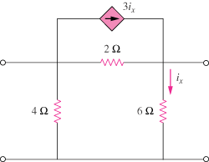

Figure 19.81
For Prob. 19.20.

